

**Reflection Activity 2.3**

Liliana Solórzano Pérez A01641392

11 de October del 2022

Programming of Data Structures and Fundamental Algorithms

(Gpo 613)

**Professors**

Jorge Enrique González

Zapata Luis Ricardo Peña Llamas

**Benefits of using double linked list**

The singly linked list allows for direct access from a list node only to the next node in the list. A doubly linked list allows convenient access from a list node to the next node and also to the preceding node on the list. The doubly linked list node accomplishes this in an obvious way by storing two pointers: one to the node following it (as in the singly linked list), and a second pointer to the node preceding it.

Like our singly linked list implementation, the doubly linked list implementation makes use of a header node. We also add a tailer node to the end of the list. The tailer is similar to the header, in that it is a node that contains no value, and it always exists. When the doubly linked list is initialized, the header and tailer nodes are created. The data member head points to the header node, and the tail points to the tailer node. The purpose of these nodes is to simplify the insert, append, and remove methods by eliminating all need for special-case code when the list is empty, or when we insert at the head or tail of the list.

In our implementation, curr will point to the current position (or to the trailer node if the current position is at the end of the list).

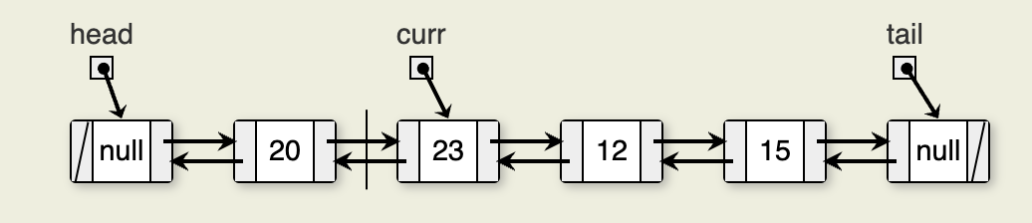

The only disadvantage of the doubly linked list as compared to the singly linked list is the additional space used. The doubly linked list requires two pointers per node, and so in the implementation presented it requires twice as much overhead as the singly linked list.

There is a space-saving technique that can be employed to eliminate the additional space requirement, though it will complicate the implementation and be somewhat slower.

**Advantages Of DLL:**

* Reversing the doubly linked list is very easy.
* It can allocate or reallocate memory easily during its execution.
* As with a singly linked list, it is the easiest data structure to implement.
* The traversal of this doubly linked list is bidirectional which is not possible in a singly linked list.
* Deletion of nodes is easy as compared to a Singly Linked List. A singly linked list deletion requires a pointer to the node and previous node to be deleted but in the doubly linked list, it only required the pointer which is to be deleted.

**Disadvantages Of DLL:**

* It uses extra memory when compared to the array and singly linked list.
* Since elements in memory are stored randomly, therefore the elements are accessed sequentially no direct access is allowed.

**Uses Of DLL:**

* It is used in navigation systems where front and back navigation is required.
* It is used by the browser to implement backward and forward navigation of visited web pages which is a back and forward button.
* It is also used to represent a classic game deck of cards.
* It is also used by various applications to implement undo and redo functionality.
* Doubly Linked List is also used in constructing MRU/LRU (Most/least recently used) cache.
* Other data structures like stacks, Hash Tables, and Binary trees can also be constructed or programmed using a doubly-linked list.
* Also in many operating systems, the thread scheduler(the thing that chooses what process needs to run at which time) maintains a doubly-linked list of all processes running at that time.

**Citas en Formato APA**

* “Advantages, Disadvantages, and Uses of Doubly Linked List.” GeeksforGeeks, 26 July 2022, https://www.geeksforgeeks.org/advantages-disadvantages-and-uses-of-doubly-linked-list.
* “CS3 Data Structures &amp; Algorithms.” 5.6. Doubly Linked Lists - CS3 Data Structures &amp; Algorithms, https://opendsa-server.cs.vt.edu/ODSA/Books/CS3/html/ListDouble.html#:~:text=The%20most%20common%20reason%20to,easier%20to%20implement%20and%20debug.